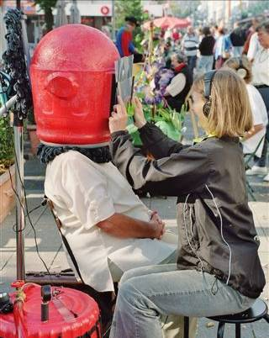
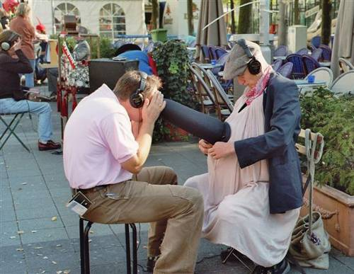

THEATRE for ONE

Street Theatre with a difference

2 short street performances lasting between 3-4 minutes.

Each performed to only one person
At a time, (plus curious onlookers!)

A most intriguing, and then exclusive, Theatre experience!

The shows are usually performed together, at the
Same time, and we can play up to 3 hours in any one day, each.

Suitable for children (from 6 years) and adults alike!

LEMPEN PUPPET THEATRE COMPANY
28 Belgrave Street, Skipton, BD23 1QB

Tel: 01756 797 149 lempen@lempen.co.uk www.lempen.co.uk

Dan’s Baby

An in-utero private view of Europe’s first “pregnant man”. Watch the cute, but rather strange baby as it moves in the belly.

Riverbed Dive

Enjoy a calming journey amidst a busy town centre. Dive to the riverbed without getting wet and find out who lives there…

