Extra information for schools LEMPEN PUPPET THEATRE COMPANY

www.lempen.co.uk / 01756797149

THE GOLDEN PRINCESS
by Lempen Puppet Theatre Company (2010)
Direction: Martin Bachmann

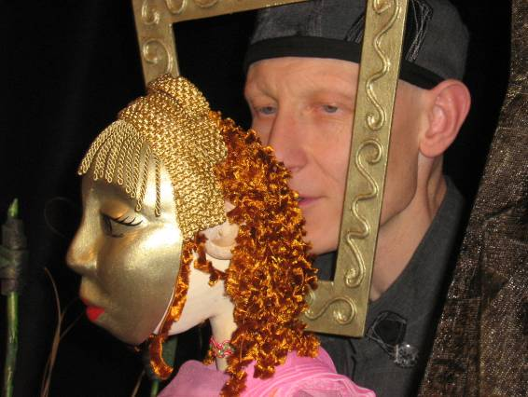

In the Kingdom of Rumours lives Princess
Suzanna the Golden. She is rich and famous
but not happy. But why is she so sad?
And what in the world will make her happy?

Only Melo, the one legged musician, has the gift to help her.

A theatrical performance using acting, puppets,
shadows and music for everyone from
5 years old to 105 years young.

* * *
Following synopsis not to be shared with the children before the show and we don’t want their understanding of the unfolding story to be pre-empted. However the themes of the story could
be explored in advance.

Melodious, Melo for short is a wonderful musician with a very special gift. He is also called “The one legged beggar” because he has no normal legs and cannot walk. Melo faces adversity. His life is hard, he is pushed in the mud, and discriminated against because he cannot walk.
Melo sails reckless into the storm, determined to leave his hardships behind. Instead he finds a place of spirit. He meets the “Keeper of Souls” at the bottom of the sea and his gift for life is revealed. He is sent back.

Princess Suzanna the Beautiful lives in the “Kingdom of Rumours” where the smallest idea can become a tremendous reality of even a lie.
Using two small hand puppets, words and phrases are played out like Chinese whispers. A Princess, as we know from our image and media crazy world, cannot do anything that is not watched and commented upon. Suzanna must live with the image created by the rumours and so she wears a golden mask and is trapped behind it.

The King decrees that anyone who can make his unhappy daughter laugh again can have half of his Kingdom and his daughters’ hand in marriage. A trio of characters then present themselves for this honour, a poet, a puppeteer and a balladeer. Each one is more ridiculous and funny than the last, but the unhappy Princess rejects them all and as they offend her sensitivity by declaring their love for her beauty, she condemns them all to live in a pig sty. We come to realise that although the Princess wears the mask of beauty, her cruelty betrays the fact that she is not beautiful on the inside.

Melo arrives with his gift of music. Suzanna rejects his offer of help and has him imprisoned. Through the walls of the prison his healing music reaches out to her and from within her own prison of unhappiness she finds a way to free herself.

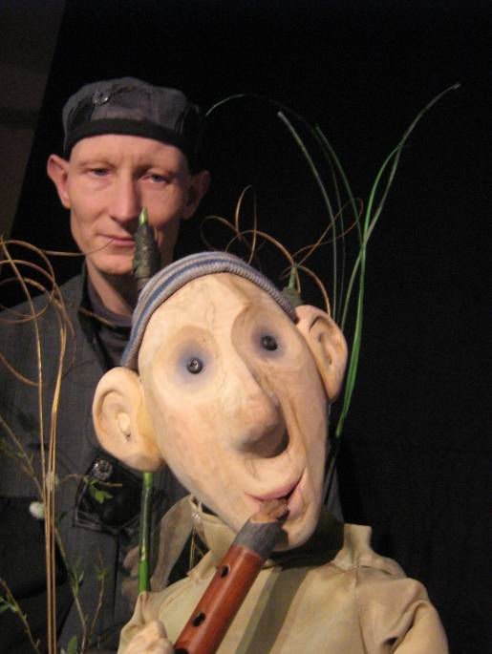

Themes
Judging people by appearances
Obsession with Beauty
Being happy with the way you look
Emotional power of music

Technicals
Set up time: 2 hours
Get out time: 1 hour
Performance: 50 minutes
Suitability: 5 - 11 year olds
Space required: 5m x 5m / darkout
Power: 2 x13amp sockets

....and a cup of coffee during the set up
is always much appreciated...

* * * *

“What a lovely show, very touching!”
Sophie Curtis, Theatre by the Lake, Keswick

*
“Thank you for an amazing afternoon watching 'Ugly Beauty'.
The music was beautiful the puppets truly wonderful and
the performance was pure genius!”
Lucy Leggott, Cheshire

LEMPEN PUPPET THEATRE COMPANY will bring all their own technical equipment (fully PAT tested), have Public Liability of £ 10.000.000 and a valid Enhanced Disclosure Certificate.

LEMPEN PUPPET THEATRE COMPANY, founded in 1987, is one of Britain’s great touring theatre companies. They tour all over the UK, and have appeared at festivals, theatres and schools all over Europe.

They specialise in modern day myths that connect the imagination to real and contemporary issues and are committed to producing entertaining, quality theatre for children and family audiences. “The Golden Princess” is their 18th production.

LEMPEN PUPPET THEATRE COMPANY
28 Belgrave Street, Skipton, North Yorkshire, BD23 1QB

Tel: 01756 797 149 lempen@lempen.co.uk www.lempen.co.uk

