THE GOLDEN PRINCESS

Melo, the strange, one legged musician, sits alone by the sea, content in his world and playing the most beautiful music. But who comes here? A golden carriage bearing a Princess so beautiful that she wears a golden mask to hide her blinding beauty. And she pushes him in the mud!

What kind of a world is this, where one who hides her beauty behaves so badly to the one with beauty at his fingertips? It is the ‘Land of Rumours’ of course – where the first idea or impression spreads like a wildfire of whispers, distorting the truth and spreading discontent.

A theatrical performance using acting, puppets,
shadows and music for everyone from
5 years old to 105 years young.

* * * * *

“What a lovely show, very touching!”
Sophie Curtis, Theatre by the Lake, Keswick

“Thanks for the show - another winner!”
June Gibbons, Rose Theatre, Ormskirk

“Thank you for an amazing afternoon watching 'Ugly Beauty'.
My two children-(and me!!) sat in awe for a whole hour!!
The music was beautiful the puppets truly wonderful and the performance was pure genius!”
Lucy Leggott, Cheshire

Duration: 55 minutes
Performer: Daniel Lempen
Direction: Martin Bachmann
Puppets: Liz Lempen
Costume: Ian Stead Costumes
Music: Lempen/Bachmann

LEMPEN PUPPET THEATRE COMPANY, is one of Britain’s great touring theatre companies. They tour all over the UK, and have appeared at festivals, theatres and schools all over Europe.

They specialise in modern day myths that connect the imagination to real and contemporary issues and are committed to producing entertaining, quality theatre for children and family audiences.

“The Golden Princess” is their 18th production.

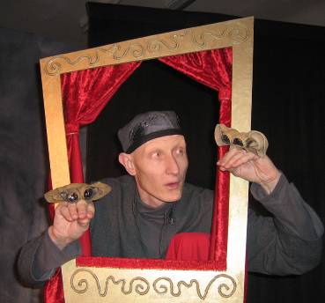

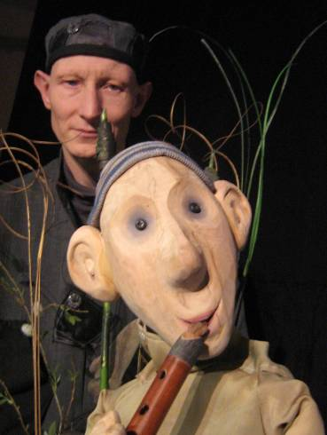

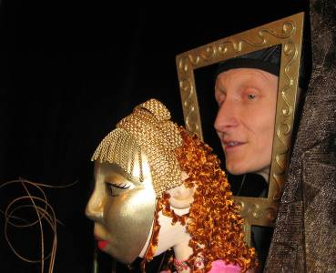

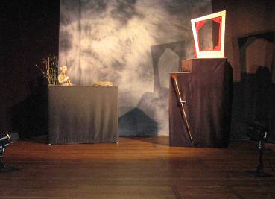

LEMPEN PUPPET THEATRE COMPANY
28 Belgrave Street, Skipton, North Yorkshire, BD23 1QB

Tel: 01756 797 149 lempen@lempen.co.uk www.lempen.co.uk

