LEMPEN PUPPET THEATRE COMPANY

TECHNICAL INFORMATION

& Risk Assessment Form (on page 2)

LITTLE FRANKENSTEIN

Performing area required: 5m wide x 4.5m deep x 3m high

Blackout: Yes

Power: 2 x 13amp sockets

Get in time: 2.5 hours

Get out time: 1 hour

Number of performers: 1
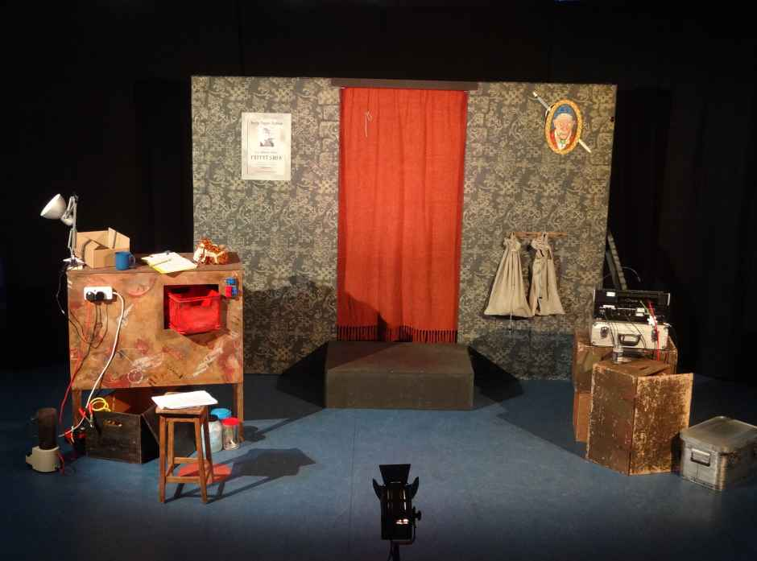
View of set up:

Sound / Lighting: LEMPEN PUPPET THEATRE COMPANY, is fully self contained and will bring their own lighting board (Z88 12 channel desk), dimmers, stands,
cables, lanterns, MD player and PA system.
(all fully PAT tested). We do not use smoke or strobe lighting.

The only thing we need is someone to operate house lights and a cup of
tea or coffee is always very much appreciated.

Public Liability: £ 10.000.000 as a member of Equity

Disclosures: Everyone working with LEMPEN PUPPET THEATRE COMPANY has a
valid Enhanced Disclosure Certificate and carries photo ID.

Important Note: Due to a recent knee operation I would appreciate help with unloading the van on my arrival. It should only take 10 minutes. Thanks!

LEMPEN PUPPET THEATRE COMPANY, 18 Airedale Terrace, Skipton, BD23 2BA

Tel: 01756 797 149 E-mail: lempen@lempen.co.uk Web: lempen@lempen.co.uk

LEMPEN PUPPET THEATRE COMPANY

18 Airedale Terrace, Skipton, BD23 2BA
Tel: 01756 797149 email: lempen@lempen.co.uk

RISK ASSESSMENT

for “Little Frankenstein”

Name and Status of the Assessor:

Daniel Lempen, Managing Director & Performer

Activity/procedure being assessed:

“Little Frankenstein” a touring theatre production using a theatrical set with staging,
props and puppets.

Known or expected hazards associated with the activity:

a) There are a few larger pieces of scenery that could fall onto the performer during the show or an audience member, (although audience is not authorised to walk in these areas).

b) There are power cables leading from the set to two stands, each carrying a few lamps.

c) One floor light on a sturdy floor stand.

The risk of injury and its severity likely to arise from these hazards:

- Performer or audience member could trip over a lighting stand, a piece of driftwood, fishing net or other piece of scenery or have a piece of scenery falling on them and hurt themselves.

Risk severity 3 out of 10

Who is at risk?

- Performer (70%) and Audience members (30%).

Measure to be taken to reduce the level of risk:

- Bigger scenery pieces are weighted down with heavy stage weights so they can’t fall.

- Cables are taped to the floor.

- Legs of lighting stands spread as far as possible to make them steady.

- Hazardous areas marked with “white gaffer tape” or special “hazard tape”.

- All electrical equipment is fully P.A.T tested every 12 months and appropriate
staging has been fire proofed.

Level of risk remaining:

- Very low level remaining with above actions taken into account.

Remaining Risk severity: 1 out of 10

Action to be taken in an emergency:

- Full attention to the victim, First aid, 999 if necessary.

