JOURNEY OF TURTLE

Produced in 2007
Play / Puppets: Liz Lempen
Direction: Martin Bachmann
Music: Daniel Lempen / Martin Bachmann

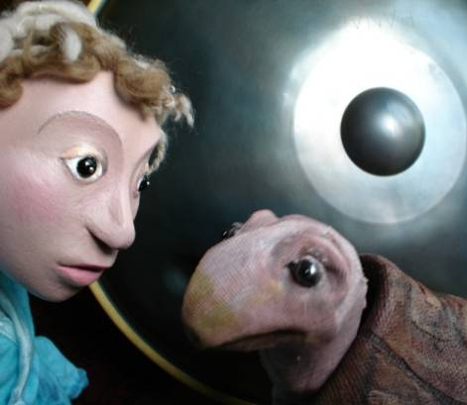
Turtles are old, millions of years old, as old as dinosaurs, as old as some hills.
Go to Turtle Hill and experience an imaginative journey through the evolution
and learning of this most fascinating and ancient creature.

In the beginning turtle was shiny and fast,
always impatient, always in a hurry,
but then one day he had a terrible accident…

A beautiful story about following your dream,
told with shadows, table-top puppets and
traditional storytelling.

Background Information


Being inspired by the magical sound and shape of the “Hang”
instrument from Bern (Switzerland), built by Panart, Lempen
Puppet Theatre have researched traditional Turtle stories from
around the world and created ‘Journey of Turtle’, a delightful
production to inspire everyone over the age of 5.

Working with September Theatre of Germany on story-work and
direction, they have produced an atmospheric and imaginative
story, full of shadows, light and music, about following your
dream.

Told with table top puppets, shadows, traditional storytelling and atmospheric sound-scape, this charming tale, created through the imagination of two children and the atmosphere of a special hill, follows the story of one particular crazy turtle.

In the beginning turtle was shiny and fast,
always impatient, always in a hurry,
but then one day he had a terrible accident…

Turtle is like all of us, often impatient, selfish, and faltering through his own mistakes. In this story we see him learning to make the important step that allows him to transform his life.

Extra Info and a Sound sample of the Hang Instrument can be found on our website www.lempen.co.uk

---------------------------------------------------------------------------------------------------------------------------------------------
LEMPEN PUPPET THEATRE, 28 Belgrave Street, Skipton, BD23 1QB
01756 797 1479 lempen@lempen.co.uk www.lempen.co.uk

