Extra information for schools LEMPEN PUPPET THEATRE COMPANY

www.lempen.co.uk / 01756797149

JOURNEY OF TURTLE

Turtles are old, millions of years old, as old as dinosaurs, as old as some hills.
Go to Turtle Hill and experience an imaginative journey through the evolution
and learning of this most fascinating and ancient creature.

In the beginning turtle was shiny and fast,
always impatient, always in a hurry,
but then one day he had a terrible accident…

A beautiful story about following your dream, told with shadows,
table-top puppets and traditional storytelling.

*
The meeting of 2 children, a boy and a girl, on Turtle Hill, is the story frame for a trilogy of “just so“ style Turtle tales tracking the evolution and learning of one particular Turtle.

Turtle Hill is a place of atmosphere, a place to listen. The Girl is sensitive to the atmosphere and music of the hill. She is inspired to write Turtle stories. The boy cannot hear the hill.

Inspired by a Native American traditional tale, in story one turtle is shiny and smooth, fast and impatient. His speed through life and his desire to travel south, cause him to have an accident where his shell becomes cracked and he is forced to become slower and more careful.

Inspired by an African tale, in story two, turtle helps his friend, Leopard, by sharing his spinach when Leopard is injured. In return, Leopard shares his meat, but Turtle double crosses
Leopard by stealing all the meat, thereby losing his friendship and becoming hunted and afraid.

Story 3 sees the same turtle, leaving behind his shell and his fear, following his dream to travel south and finally learning to fly. This is a transformational, “Lempen” tale, about leaving your limitations behind and following your dream.

During story three, the boy has learned to listen and can finally hear the hill. He finishes the story and so the children begin a journey of the imagination together on the back of Turtle Hill.

Themes
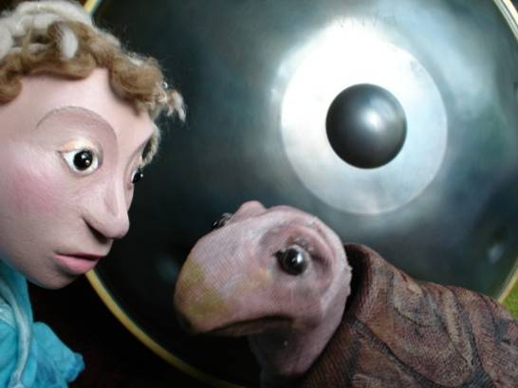
Turtles
Learning through mistakes
Following your dream
Learning to listen
Using your imagination
Atmosphere and special places

Technicals
Set up time: 2 hours
Get out time: 1 hour
Performance: 50 minutes
Suitability: 5 - 11 year olds
Space required: 5m x 5m / darkout
Power: 2 x13amp sockets

LEMPEN PUPPET THEATRE COMPANY will bring all their own technical equipment (fully PAT tested), have Public Liability of £ 10.000.000 and everyone performing has a valid Enhanced Disclosure Certificate.

Background Information


Being inspired by the magical sound and shape of the “Hang” instrument from Bern (Switzerland), built by Panart, Lempen Puppet Theatre have researched traditional Turtle stories from around the
world and created ‘Journey of Turtle’, a delightful production to inspire everyone over the age of 5.

Working with September Theatre of Germany on story-work and direction, they have produced an atmospheric and imaginative
story, full of shadows, light and music, about following your dream.

Told with table top puppets, shadows, traditional storytelling and atmospheric sound-scape, this charming tale, created through the imagination of two children and the atmosphere of a special hill, follows the story of one particular crazy turtle.

In the beginning turtle was shiny and fast,
always impatient, always in a hurry,
but then one day he had a terrible accident…

Turtle is like all of us, often impatient, selfish, and faltering through his own mistakes. In this story we see him learning to make the important step that allows him to transform his life.

! Extra Info and a Sound sample of the Hang Instrument can be found on our website www.lempen.co.uk

Note: Please limit the amount of story you tell the children in advance. We don’t want them to know what happens before they see it. The above information is for preparation work.

Contact:

LEMPEN PUPPET THEATRE
Liz and Daniel Lempen
28 Belgrave Street
Skipton
North Yorkshire
BD23 1QB
01756 797 149
lempen@lempen.co.uk
www.lempen.co.uk

