More info / descriptions and High Resolution Photos you can get from our website www.lempen.co.uk

JOURNEY OF TURTLE

Suitability: Everyone over 5
Duration: 50 minutes - no interval
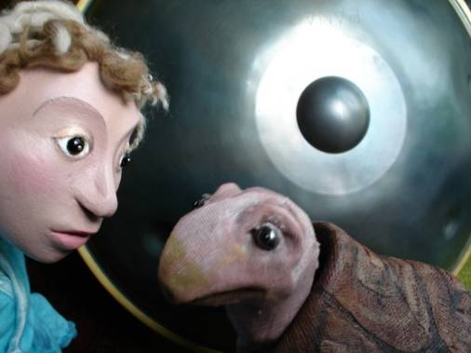

An imaginative, evolutionary journey of this most fascinating
and ancient creature.

In the beginning turtle was shiny and fast,
always impatient, always in a hurry,
but then one day he had a terrible accident…

A beautiful story about following your dream, told with shadows,
table-top puppets and traditional storytelling.

“I came to your show last night with my two children and wanted to say what a beautiful
performance it was. Amazing story, well told, soothing music ....... I could go on”.
Parent after a show at Merlin Theatre, Sheffield
“A really beautiful and inspiring show. Completely absorbed both my children. Thank you!”
Mother, Mayfield Centre, Dalkeith (Scottish Puppet Festival 08)

“The story-telling was really clear and engaging and the puppets were beautifully made and performed.
I loved the way you could put so much humour in it with the raise of an eyebrow!”
Kathy Bradley, Thingumajig Theatre

Background Information


Being inspired by the magical sound and shape of the “Hang” instrument from Bern (Switzerland), built by Panart, Lempen Puppet Theatre have researched traditional Turtle stories from around the world and created ‘Journey of Turtle’, a delightful production to inspire everyone over the age of 5.

Working with September Theatre of Germany on story-work and direction, they have produced an atmospheric and imaginative story, full of shadows, light and music, about following your dream.

Told with table top puppets, shadows, traditional storytelling and atmospheric sound-scape, this charming tale, created through the imagination of two children and the atmosphere of a special hill, follows the story of one crazy turtle.

In the beginning turtle was shiny and fast,
always impatient, always in a hurry,
but then one day he had a terrible accident…

Turtle is like all of us, often impatient, selfish, and faltering through his own mistakes. In this story we see him learning to make the important step that allows him to transform his life.

LEMPEN PUPPET THEATRE COMPANY, founded in 1987, is one of Britain’s great touring theatre companies. They tour all over the UK, and have appeared at festivals, theatres and schools all over Europe.

They specialise in modern day myths that connect the imagination to real and contemporary issues and are committed to producing entertaining, quality theatre for children and family audiences.

LEMPEN PUPPET THEATRE COMPANY
28 Belgrave Street, Skipton, North Yorkshire, BD23 1QB

Tel: 01756 797 149 lempen@lempen.co.uk www.lempen.co.uk

