The am-A-zing Thing

Produced by Liz and Daniel Lempen in 2006
Direction: Caroline Astell-Burt
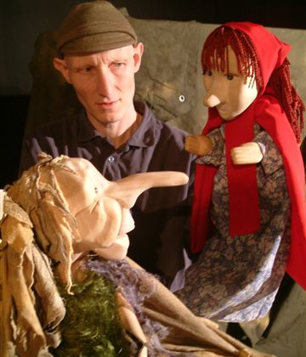

“As I was walking down the beach, one bright and sunny day,
I saw a great big wooden box, a-floating in the bay.
I pulled it in and opened it up, and there to my surprise,
I discovered a ...?..?..?... right before my eyes!”

What’s in the box? A strange and weird thing? Something terrible, or a thing of beauty?

Storyteller, Peter Grimm opens the box to find the ‘Thing’ that takes him on an unusual
journey that weaves it’s way through a medley of well known Brother’s Grimm tales,
to finally unlock his imagination and free his stories.

A truly original story told with puppets, acting and live music.

Fun, inspiration and delight for all the family.

Suitability: 5+ and family / Duration: 55 minutes

Peter Grimm is a descendent of the famous Brothers Grimm. He has inherited the tradition of his ancestors and tells the their stories as they were written down 200 years ago.

But, with his inheritance also comes a ghost. The brothers locked something away in a box when they wrote down and fixed the stories. They threw the box into the sea, and now that something, that rogue and wild element of story, has returned with the tide. Peter opens the box and sets free the “amazing thing” to add it’s influence in the sea of stories.

The show is about the unlocking of imagination in relation to stories, hung on some well known Grimm classics. It can be useful to start somewhere familiar and then take a detour into the unknown. A rogue or surprise element can wake up the imagination and give a new slant to a predictable tale.

LEMPEN PUPPET THEATRE COMPANY, is one of Britain’s great touring theatre companies. They tour all over the UK, and have appeared at festivals, theatres and schools in Ireland, Switzerland, Austria, Germany, Greece and the Czech Republic.

They specialise in modern day myths that connect the imagination to real and contemporary issues and are committed to producing entertaining, quality theatre for children and family audiences.

LEMPEN PUPPET THEATRE COMPANY
28 Belgrave Street, Skipton, North Yorkshire, BD23 1QB

Tel: 01756 797 149 lempen@lempen.co.uk www.lempen.co.uk

