Some extra information and suggestions for Schools

The am-A-zing Thing

Produced by Liz and Daniel Lempen in 2006

“As I was walking down the beach, one bright and sunny day,
I saw a great big wooden box, a-floating in the bay.
I pulled it in and opened it up, and there to my surprise,
I discovered a ...?..?..?... right before my eyes!”

What’s in the box? A strange and weird thing?
Something terrible, or a thing of beauty?

Storyteller, Peter Grimm opens the box to find the ‘Thing’
that takes him on an unusual journey that weaves it’s way
through a medley of well known Brother’s Grimm tales,
to finally unlock his imagination and free his stories.

A truly original story told with puppets, acting and live music.

Fun, inspiration and delight for all the family.

Suitability: 5+ and family
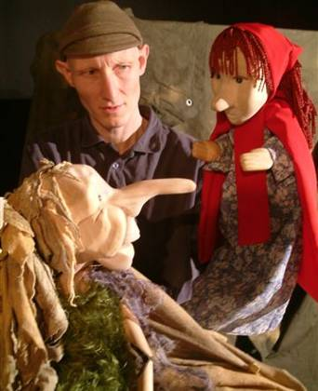
Duration: 50 minutes

LEMPEN PUPPET THEATRE COMPANY, founded in 1987, is one of Britain’s great touring theatre companies. They tour all over the UK, and have appeared at festivals, theatres and schools in Ireland, Switzerland, Austria, Germany, Greece and the Czech Republic.

They specialise in modern day myths that connect the imagination to real and contemporary issues and are committed to producing entertaining, quality theatre for children and family audiences.

LEMPEN PUPPET THEATRE COMPANY
28 Belgrave Street, Skipton, North Yorkshire, BD23 1QB

Tel: 01756 797 149 lempen@lempen.co.uk www.lempen.co.uk

WHAT’S IT ALL ABOUT

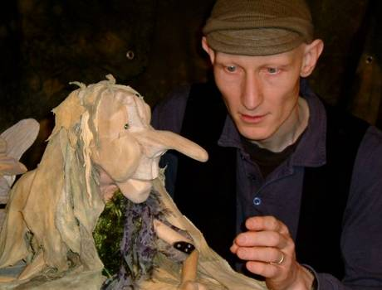
Peter Grimm is a descendent of the famous Brothers Grimm.
He has inherited the tradition of his ancestors and tells the
their stories as they were written down 200 years ago.

But, with his inheritance also comes a ghost. The brothers
locked something away in a box when they wrote down and
fixed the stories. They threw the box into the sea, and now
that something, that rogue and wild element of story, has
returned with the tide. Peter opens the box and sets free
the “amazing thing” to add it’s influence in the sea of stories.

The show is about the unlocking of imagination in relation to stories. We have hung this on some well known Grimm classics. It can be useful to start somewhere familiar and then take a detour into the unknown. A surprise or rogue element can wake up the imagination and give a new slant and dramatic tension to a predictable tale.

THE BROTHERS GRIMM

Born in 1785 in Germany, Jakob Grimm and his younger brother Wilhelm are famous for their collections of folk/fairy tales. The brothers did not invent these stories, but collected them by travelling around the countryside and listening to village storytellers.

These old stories would have never been written down before, but passed from one teller to the next in the aural tradition. The brothers came across many variations of the same stories on their travel, that must have reflected the memories, personalities and imaginations of the tellers. Then they wrote down the tales and had to choose what they felt were the best, most definitive versions. What they wrote is now knows as “The Complete Fairy Tales of the Brothers Grimm” and contains more than 200 stories.

Amongst their most famous stories are:

Snow White - The Frog Prince Rumpelstiltskin - The Wolf and the Seven Little Kids - Cinderella -
The Fisherman and his Wife - The Brave Little Taylor - Little Red Cap (Little Red Riding Hood) -
Sleeping Beauty - The Bremen Town Musicians - Tom Thumb - Hansel and Grethel

Question:

How many do your children know?

The stories that we use/refer to in “The am-A-zing Thing” are:

- Little Red Riding Hood
- The Frog Prince
- Rapunzel

Do your children know these stories? If not it might be helpful for you to read the ones they don’t before the performance

After Show Exercise:

After the performance try retelling a well known story, but halfway through add something different, some new character or element.

Suggestion:

Take a small box or bag and put in several objects. Split the children into groups of 3 or 4 and get them to retell a favourite well known story in turn, about 2 – 3 sentences each. At 3 or 4 places in the story the teller must take an object out of the bag and incorporate it into the tale.

